**A**

**PROJECT REPORT**

**ON**

**“Battleship Console Game Using JAVA”**

**FOR COURSE**

**ADVANCED OBJECT ORIENTED PROGRAMMING**

**(4340701)**

**GUIDED BY: PREPARED BY:**

**Suthar Manthan Sumantkumar: 226240307068**

**Ms. A.R.SHAH**

**DIPLOMA IN 4TH SEMESTER**

**COMPUTER ENGINEERING DEPARTMENT**



**CERTIFICATE**

This is to certify that the micro - project entitled “Battleship Console Game Using JAVA” submitted by Suthar Manthan Sumantkumar(226240307068) towards the partial fulfillment of the requirement for Continuous Assessment (CA) to facilitate integration of Course Outcomes (COs) in Advanced Object Oriented Programming (4340701) is a record of the work carried out by him/her under my guidance and supervision. The work submitted, in my opinion, has to a level required for being accepted for the examination.

|  |  |
| --- | --- |
| Guided By:  **Mrs. A. R. Shah**  Government Polytechnic,  Himatnagar – 380001 | Head of the Department:  **Mrs. M. P. Mehta**  Government Polytechnic,  Himatnagar - 380001 |

**TABLE OF CONTENTS**

|  |  |  |
| --- | --- | --- |
| No. | Point | Page |
| 1 | Brief Description | 1 |
| 2 | Aim of Micro Project | 1 |
| 3 | Course Outcomes Integrated | 1 |
| 4 | Actual Procedure Followed | 2-9 |
| 5 | Outputs of the Micro-projects | 10-11 |
| 6 | Actual Resources Used | 11 |
| 7 | Skill Developed/ learning out of this Micro-Project | 12 |

1. **Brief Description**

"Battleship Console Game Using JAVA" is a micro project will involve creating a console-based interface where players can interact with the game by inputting their guesses for the ship locations (as row and column) and receiving feedback on whether their guesses were hits or misses. The game will be one player, where the player will play and the result will be count as per how many attempt the user get to hit the number of ship as per the rules given by in the game already. The game will include features such as displaying the game board, keeping track of the numbers of how many ships were hit and multiple options of the grid of game board i.e. 4x4, 5x5, 6x6, 8x8; each layout contain different rules.

**2.0 Aim of Micro Project**

"Battleship Console Game Using JAVA" is a micro project aimed at implementing the classic Battleship game in the Java programming language. In this project, players will engage in a strategic naval battle type game where they have to guess the coordinates of the ship in game board grid and attempt to sink the ships by guessing their coordinates and if the guessed coordinates will contains the ship then the ship will sink which means hit; and if the ship does not found at coordinates then it is miss.

**3.0 Course Outcomes Integrated**

|  |  |
| --- | --- |
| 4340701.1 | Write simple java programs for a given problem statement. |
| 4340701.2 | Use object oriented programming concepts to solve real world problems. |
| 4340701.3 | Develop an object-oriented program using inheritance and package concepts for a given problem statement. |
| 4340701.4 | Develop an object oriented program using multithreading and exception handling for a given problem statement. |
| 4340701.5 | Develop an object-oriented program by using the files and collection framework. |

**4.0 Actual Procedure Followed**

import java.util.Arrays;

import java.util.Random;

import java.util.Scanner;

public class BattleshipGame {

    public static Scanner input = new Scanner(System.in);

    public static void main(String[] args) {

        boolean playAgain = false;

        do{

            int userSize = 0;

            System.out.println("\n<-- Welcome to Battleship console game -->");

            System.out.println("\nEnter '1' for 4x4 board\nEnter '2' for 5x5 board\nEnter '3' for 6x6 board\nEnter '4' for 8x8 board");

            System.out.println("Note: The more size of matrix of game board, the more hard the game will.\n");

            do{

            System.out.print("Enter the number of Game board you want to play in: ");

            userSize = input.nextInt();

            } while(userSize < 1 || userSize > 4);

            switch (userSize) {

                case 1:Game4x4();

                    break;

                case 2:Game5x5();

                    break;

                case 3:Game6x6();

                    break;

                case 4:Game8x8();

                    break;

            }

            char playAgainChoice='y';

            do{

                System.out.print("Wanna play again? [Y]yes or [N]no:");

                playAgainChoice = Character.toUpperCase(input.next().charAt(0));

            } while (playAgainChoice != 'Y' && playAgainChoice != 'N');

            if(playAgainChoice == 'Y'){

                playAgain = true;

            } else {

                playAgain = false;

            }

        }while(playAgain == true);

    }

    //method to create a game for 4x4

    public static void Game4x4(){

        String boardName = "Game4x4";

        int Attempts = 0;

        int gameBoardLength = 4; //lenght of x and y axis of board

        char water = '-'; //char to fill water in board

        char ship = 'S'; //char to fill ship in board

        char hit = 'X'; //char to fill hit symbol after hiting a ship

        char miss = 'O'; //char to fill miss symbol after missing hit

        int shipNumber = 3; //total number of ships to be hit

        System.out.println("\n___YOU SELECT THE 4x4 BOARD TO PLAY GAME___");

        System.out.println("------------------RULES--------------------");

        System.out.println("> You have to enter row and column numbers to hit at the particular target in game board.");

        System.out.println("> If the ship found in that target it will hit otherwise its miss.");

        System.out.println("> You have to hit 3 ships in 4x4 game board to win!\n");

        char[][] gameBoard = createGameBoard(gameBoardLength, water, ship, shipNumber); //creating game board

        showGameBoard(gameBoard, water, ship); //displaying Game Board

        int undetectedShipNumber = shipNumber;

        while(undetectedShipNumber > 0){

            Attempts++;

            int[] guessCoordinates = getUserCoordinates(gameBoardLength); //user's row and column choices stored in one-dimentional array

            char[] locationViewUpdate = evaluateUserGuessAndGetTheTarget(guessCoordinates, gameBoard, ship, water, hit, miss); //this char is to store what contains in the targated place in game board

            if (locationViewUpdate[0] == hit && locationViewUpdate[1]=='H') { //if the user's targated place contains ship the value of locationVeiwUpadte will be 'X' which is hit that means ship is hit

                undetectedShipNumber--; //decrementing whenever ship found to confirm how many ship is left to hit

                /*

                 * when undetectedShipNumber will be 0 it means there is no ship is left to hit

                 * and all the given ships are hitted or found

                 * so this while loop will terminate

                 */

            }

            gameBoard = updateGameBoard(gameBoard, guessCoordinates, locationViewUpdate); //update method calling to update the game board after users guessed place

            showGameBoard(gameBoard, water, ship); //displaying game board after users guess

        }

        winOutput(Attempts, boardName, shipNumber);//displaying won message after user succesfully hit all the ships

    }

    //method to create a game for 5x5

//all comments from 4x4 is same here

    public static void Game5x5(){

        String boardName = "Game5x5";

        int Attempts = 0;

        int gameBoardLength = 5;

        char water = '-';

        char ship = 'S';

        char hit = 'X';

        char miss = 'O';

        int shipNumber = 4;

        System.out.println("\n___YOU SELECT THE 5x5 BOARD TO PLAY GAME___");

        System.out.println("------------------RULES--------------------");

        System.out.println("> You have to enter row and column numbers to hit at the particular target in game board.");

        System.out.println("> If the ship found in that target it will hit otherwise its miss.");

        System.out.println("> You have to hit 4 ships in 5x5 game board to win!\n");

        char[][] gameBoard = createGameBoard(gameBoardLength, water, ship, shipNumber); //creating game board

        showGameBoard(gameBoard, water, ship); //displaying Game Board

        int undetectedShipNumber = shipNumber;

        while(undetectedShipNumber > 0){

            Attempts++;

            int[] guessCoordinates = getUserCoordinates(gameBoardLength);

            char[] locationViewUpdate = evaluateUserGuessAndGetTheTarget(guessCoordinates, gameBoard, ship, water, hit, miss);

            if (locationViewUpdate[0] == hit && locationViewUpdate[1] == 'H') {

                undetectedShipNumber--;

            }

            gameBoard = updateGameBoard(gameBoard, guessCoordinates, locationViewUpdate); //update method calling to update the game board after users guessed place

            showGameBoard(gameBoard, water, ship); //displaying game board after users guess

        }

        winOutput(Attempts, boardName, shipNumber);//displaying won message after user succesfully hit all the ships

    }

//method to create a game for 6x6

//all comments from 4x4 is same here

    public static void Game6x6(){

        String boardName = "Game6x6";

        int Attempts = 0;

        int gameBoardLength = 6;

        char water = '-';

        char ship = 'S';

        char hit = 'X';

        char miss = 'O';

        int shipNumber = 6;

        System.out.println("\n___YOU SELECT THE 6x6 BOARD TO PLAY GAME___");

        System.out.println("------------------RULES--------------------");

        System.out.println("> You have to enter row and column numbers to hit at the particular target in game board.");

        System.out.println("> If the ship found in that target it will hit otherwise its miss.");

        System.out.println("> You have to hit 6 ships in 6x6 game board to win!\n");

        char[][] gameBoard = createGameBoard(gameBoardLength, water, ship, shipNumber); //creating game board

        showGameBoard(gameBoard, water, ship); //displaying Game Board

        int undetectedShipNumber = shipNumber;

        while(undetectedShipNumber > 0){

            Attempts++;

            int[] guessCoordinates = getUserCoordinates(gameBoardLength);

            char[] locationViewUpdate = evaluateUserGuessAndGetTheTarget(guessCoordinates, gameBoard, ship, water, hit, miss);

            if (locationViewUpdate[0] == hit && locationViewUpdate[1] == 'H') {

                undetectedShipNumber--;

            }

            gameBoard = updateGameBoard(gameBoard, guessCoordinates, locationViewUpdate); //update method calling to update the game board after users guessed place

            showGameBoard(gameBoard, water, ship); //displaying game board after users guess

        }

        winOutput(Attempts, boardName, shipNumber);//displaying won message after user succesfully hit all the ships

    }

    //method to create a game for 8x8

//all comments from 4x4 is same here

    public static void Game8x8(){

        String boardName = "Game8x8";

        int Attempts = 0;

        int gameBoardLength = 8;

        char water = '-';

        char ship = 'S';

        char hit = 'X';

        char miss = 'O';

        int shipNumber = 7;

        System.out.println("\n___YOU SELECT THE 8x8 BOARD TO PLAY GAME___");

        System.out.println("------------------RULES--------------------");

        System.out.println("> You have to enter row and column numbers to hit at the particular target in game board.");

        System.out.println("> If the ship found in that target it will hit otherwise its miss.");

        System.out.println("> You have to hit 7 ships in 8x8 game board to win!\n");

        char[][] gameBoard = createGameBoard(gameBoardLength, water, ship, shipNumber);

        showGameBoard(gameBoard, water, ship);

        int undetectedShipNumber = shipNumber;

        while(undetectedShipNumber > 0){

            Attempts++;

            int[] guessCoordinates = getUserCoordinates(gameBoardLength);

            char[] locationViewUpdate = evaluateUserGuessAndGetTheTarget(guessCoordinates, gameBoard, ship, water, hit, miss);

            if (locationViewUpdate[0] == hit && locationViewUpdate[1] == 'H') {

                undetectedShipNumber--;

            }

            gameBoard = updateGameBoard(gameBoard, guessCoordinates, locationViewUpdate);

            showGameBoard(gameBoard, water, ship);

        }

        winOutput(Attempts, boardName, shipNumber);//displaying won message after user succesfully hit all the ships

    }

    //method to create game board

    private static char[][] createGameBoard(int gameBoardLength, char water, char ship, int shipNumber) {

        char[][] gameBoard = new char[gameBoardLength][gameBoardLength]; //board using two-dimensional

        for(char[] row : gameBoard){ //iterating through every row in gameBoard

            Arrays.fill(row, water); //filling every row with water at first

        }

        return placeShip(gameBoard, shipNumber, water, ship); //calling a method directly to place ships after creating game board with water

    }

    //method to update game board as per users guess to hit ship

    private static char[][] updateGameBoard(char[][] gameBoard, int[] guessCoordinates, char[] locationViewUpdate) {

        int row = guessCoordinates[0]; //copying row number given by user in row element from array

        int col = guessCoordinates[1]; //copying column number given by user in col element from array

        gameBoard[row][col] = locationViewUpdate[0]; //changing the target place with users guessed value

        return gameBoard;

    }

    //method to evaluate users guessed target and check what's at that target

    protected static int hittedShip = 0;

    private static char[] evaluateUserGuessAndGetTheTarget(int[] guessCoordinates, char[][] gameBoard, char ship, char water,

            char hit, char miss) {

        String message;

        char mesg;

        int row = guessCoordinates[0]; //copying row number given by user in row element from array

        int col = guessCoordinates[1]; //copying column number given by user in col element from array

        char target = gameBoard[row][col]; //storing what is contains in the user's targated place

        if (target == ship) {

            hittedShip++;

            message = "Hit!"; //if the target contains ship, it will be hit

            mesg = 'H';

            target = hit; //storing hit char 'X' in target

        } else if (target == water) {

            message = "Miss!"; //if the target contains water and does not contains ship, it will miss

            mesg = 'M';

            target = miss; //storing miss char 'O' in target

        } else {

            message = "Already Hit!"; //when when target does not contains either ship or water it simply means it is already hitted by user and the 'X' hit char is stored at that place

            mesg = 'A';

        }

        System.out.println(message); //displaying message

       return new char[]{target,mesg};

    }

    //getting input number of row and column for game board

    private static int[] getUserCoordinates(int gameBoardLength) {

        int row, col;

        //inputing number for row

        do{

            System.out.print("Row: ");

            row = input.nextInt();

        } while(row < 1 || row > gameBoardLength); //if user input invalid number eg. a number out of bound or range of the game board which is 4

        //inputing number for column

        do{

            System.out.print("Column: ");

            col = input.nextInt();

        } while(col < 1 || col > gameBoardLength);

        return new int[]{row - 1, col - 1}; //returning the decremented numbers to set that number as index

    }

    //method to print Game board in output

    private static void showGameBoard(char[][] gameBoard, char water, char ship) {

        int gameBoardLength = gameBoard.length; //length of game board which will be 4

        System.out.print("  "); //this space is to display the numbers for column in format

        for(int i = 0; i < gameBoardLength; i++){ //printing the number of columns

            System.out.print(i + 1 + " ");

        } System.out.println(); //for formated output

        for(int row = 0; row < gameBoardLength; row++){

            System.out.print(row + 1 + " "); //printing the number of rows

            for(int col = 0; col < gameBoardLength; col++){ //printing the Game Board

                char position = gameBoard[row][col]; //storing what is in the position after every iteration

                if(position == ship){

                    System.out.print(water + " "); //if the position contains ship then the water '-' will be print to hide that from the user for no cheating

                } else {

                    System.out.print(position + " "); //if the position does not cointains ship

                }

            } System.out.println(); //for formated output

        } System.out.println("Hitted ship number: "+hittedShip+"\n"); //this will print how many ship has been hit by user after each try

    }

    //method to place ship in game board at random places

    private static char[][] placeShip(char[][] gameBoard, int shipNumber, char water, char ship) {

        int placedShip = 0; //to Attempts how many ships has been placed

        int gameBoardLength = gameBoard.length; //length of game board which will be 4

        while (placedShip < shipNumber) {

            //generateShipCoordinates method will return the random coordinates to place ship at that coordinates in the game board

            int[] location = generateShipCoordinates(gameBoardLength); //calling generateShipCoordinates method to find where the ship will be placed in gameBoard array and storing that data in location[][] array

            char possiblePlacement = gameBoard[location[0]][location[1]]; //checking if the placement is possible or not. it not possible when the location in gameBoard contains any other than water

            if(possiblePlacement == water){

                gameBoard[location[0]][location[1]] = ship; //if the location only contains water then ship will be placed

                placedShip++;

            }

        }

        return gameBoard;

    }

    //method to generate random coordinates for ship placing

    private static int[] generateShipCoordinates(int gameBoardLength) {

        int[] coordinates = new int[2]; //creating an array with one row and two column to store x-axis and y-axis numbers

        for(int i=0; i < coordinates.length; i++) {

            coordinates[i] = new Random().nextInt(gameBoardLength); //storing random numbers so the game will change the place of ship every time

        }

        return coordinates;

    }

    //method to print winner output after completion of game

    private static void winOutput(int Attempts, String boardName, int shipNumber){

        //if..else to first check what game board user have chose to play in and give output accordingly

        if (boardName == "Game4x4") {

            if (Attempts >= 3 && Attempts <= 5) {

                System.out.println("You hit "+shipNumber+" Ships successfully, You Won!");

                System.out.println("You take only "+Attempts+" Attempts to win in a 4x4 board, Wonderful!");

            } else if (Attempts > 5 && Attempts <= 10) {

                System.out.println("You hit "+shipNumber+" Ships successfully, You Won!");

                System.out.println("You take "+Attempts+" Attempts to win in a 4x4 board, Good!");

            } else {

                System.out.println("You hit "+shipNumber+" Ships successfully, You Won!");

                System.out.println("You take total "+Attempts+" Attempts to win in a 4x4 board, you can try again to perform more.");

            }

        } else if (boardName == "Game5x5") {

            if (Attempts >= 4 && Attempts <= 6) {

                System.out.println("You hit "+shipNumber+" Ships successfully, You Won!");

                System.out.println("You take only "+Attempts+" Attempts to win in a 5x5 board, Wonderful!");

            } else if (Attempts > 6 && Attempts <= 15) {

                System.out.println("You hit "+shipNumber+" Ships successfully, You Won!");

                System.out.println("You take "+Attempts+" Attempts to win in a 5x5 board, Good!");

            } else if (Attempts > 15 && Attempts <= 20) {

                System.out.println("You hit "+shipNumber+" Ships successfully, You Won!");

                System.out.println("You take total "+Attempts+" Attempts to win in a 5x5 board, good but you can perform more.");

            } else {

                System.out.println("You hit "+shipNumber+" Ships successfully, You Won!");

                System.out.println("You take total "+Attempts+" Attempts to win in a 5x5 board, you can try again to perform more.");

            }

        } else if (boardName == "Game6x6") {

            if (Attempts >= 6 && Attempts <= 8) {

                System.out.println("You hit "+shipNumber+" Ships successfully, You Won!");

                System.out.println("You take only "+Attempts+" Attempts to win in a 6x6 board, Wonderful!");

            } else if (Attempts > 8 && Attempts <= 15) {

                System.out.println("You hit "+shipNumber+" Ships successfully, You Won!");

                System.out.println("You take "+Attempts+" Attempts to win in a 6x6 board, Good!");

            } else if (Attempts > 15 && Attempts <= 20) {

                System.out.println("You hit "+shipNumber+" Ships successfully, You Won!");

                System.out.println("You take total "+Attempts+" Attempts to win in a 6x6 board, good but you can perform more.");

            } else {

                System.out.println("You hit "+shipNumber+" Ships successfully, You Won!");

                System.out.println("You take total "+Attempts+" Attempts to win in a 6x6 board, as the game board is complex it is obviously hard but you can try again to perform more.");

            }

        } else if (boardName == "Game8x8") {

            if (Attempts >= 7 && Attempts <= 10) {

                System.out.println("You hit "+shipNumber+" Ships successfully, You Won!");

                System.out.println("You take only "+Attempts+" Attempts to win in a 8x8 board, Wonderful!");

            } else if (Attempts > 10 && Attempts <= 17) {

                System.out.println("You hit "+shipNumber+" Ships successfully, You Won!");

                System.out.println("You take "+Attempts+" Attempts to win in a 8x8 board, Good!");

            } else if (Attempts > 17 && Attempts <= 22) {

                System.out.println("You hit "+shipNumber+" Ships successfully, You Won!");

                System.out.println("You take total "+Attempts+" Attempts to win in a 8x8 board, good but you can perform more.");

            } else if (Attempts > 22 && Attempts <= 30) {

                System.out.println("You hit "+shipNumber+" Ships successfully, You Won!");

                System.out.println("You take total "+Attempts+" Attempts to win in a 8x8 board, it's a big game board so it is obvious to take more attempts.");

            } else {

                System.out.println("You hit "+shipNumber+" Ships successfully, You Won!");

                System.out.println("You take total "+Attempts+" Attempts to win in a 8x8 board, as the game board is complex it is obviously hard but you can try again to perform more.");

            }

        }

    }

}

**5.0 Outputs of the Micro-projects**

5.1 Screenshot of complete output:

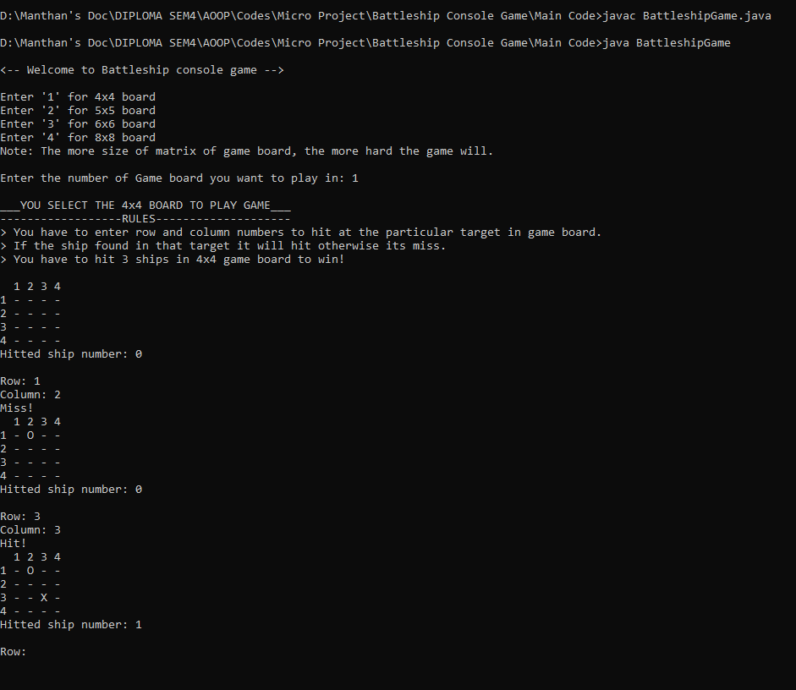

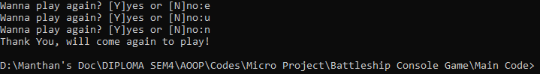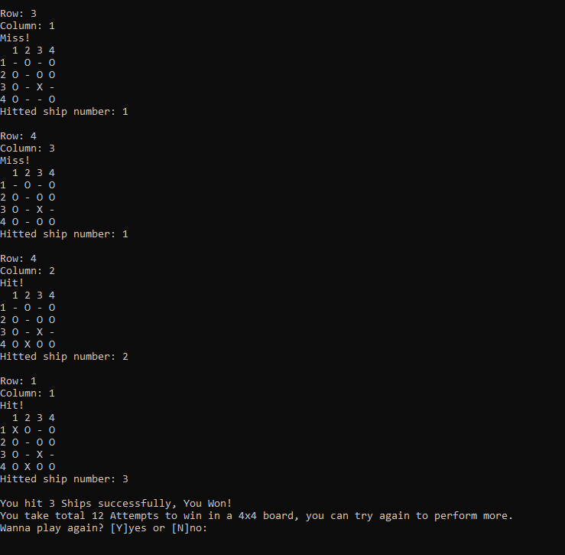

5.2 Output of validating only valid input from user:

5.2.1 Game board selecting:

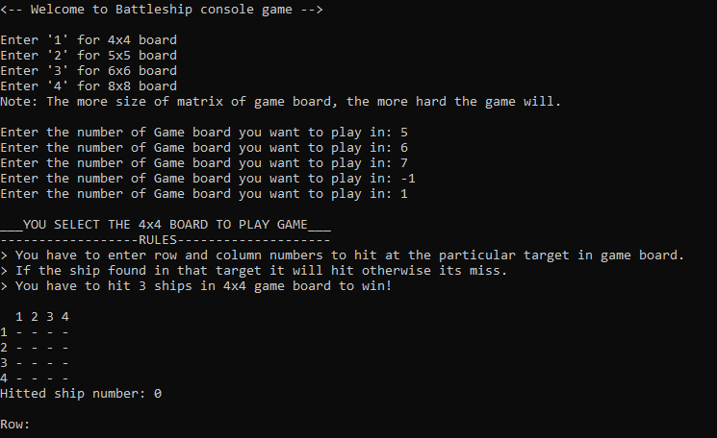

5.2.2 Input rows and columns:

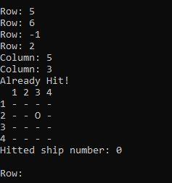

**6.0 Actual Resources Used**

|  |  |  |
| --- | --- | --- |
| **Sr. No** | **Name of Resource/material** | **Remarks** |
| **1** | Hardware: Computer System | Computer (AMD), RAM: 8 GB |
| **2** | Software: Operating System | Windows 10 Pro |
| **3** | Software | JDK 1.8.0 or above, Notepad++, VS Code or other text editor |

**7.0 Skill Developed/ learning out of this Micro-Project**

Through this micro project, I gain hands-on experience with Java programming concepts such as object-oriented design, arrays, loops, conditional statements, and user input/output handling. I also learn problem-solving and algorithmic thinking while implementing the game logic and user interface. Overall, the "Battleship Console Game Using JAVA" micro project provides an engaging and practical way for Java learners to reinforce their programming skills while having fun with a classic game.

Here are few main skills I learnt in details:

1. Java Programming: Enhanced proficiency in Java programming language, including syntaxes and object-oriented principles.
2. Object-oriented design: Improved ability to design and implement object-oriented solutions to complex problems using class, objects and methods.
3. Algorithmic thinking: Strengthened problem-solving skills through implementing algorithms for game logic, such as ship placement and hit detection.
4. User Input Handling: Experience in handling user input validation and processing to ensure smooth interaction with the game by only inputting correct and reliable inputs from user.
5. Game State Management: Proficiency in managing the state of the game, including tracking ship positions, hits, and misses, as well as determining game outcomes.
6. Testing and Debugging: Practiced techniques for testing code functionality, identifying bugs, and debugging errors to ensure the game(or code) runs smoothly without any error.